2005 Washington Children’s Choice Picture

Book Award Activity Packet

An Interview with Harry the Tarantula by Leigh Ann Tyson illustrated by Henrik Drescher
Talk show host Katy Did, of KBUG Radio, interviews a special guest, Harry the Tarantula, who tells her listeners lots of wild things about spiders! Nosy Katy questions the hairy spider about his latest adventure—being captured in a bottle by an inquisitive child. Then she pries into Harry’s personal life to get "the latest chirp" about tarantula size, diet, poisonous bites, and other juicy details.

Activity:

Reader’s Theatre Research Project
The winning combination of information and humor in this book suggests a model for a student research project for which the final product is a Reader’s Theatre presentation.
1. Students will work with a partner. Each pair will be assigned an insect or spider to “interview.”
- Teacher and librarian will gather together a variety of print and web resources for students to use in their research.
- Each pair will come up with a list of interview questions—information they would like to find out and share about their spider/insect. If preferred the class can brainstorm possible questions first. One way to do this would be to use the tarantula facts in the back of Harry as a basis for questions.
- Students will take notes using the school’s preferred format for note-taking.
- The “final product” or synthesis will be a Reader’s Theatre type interview. Each pair of students will write a script using the research they have done. Some focus should be on getting the “voice” right.
- Students will perform their interview for the total class. Audience will evaluate students according to a rubric that looks at quality of information, presentation skills, and humor in presentation.
- If desired students can create artwork that illustrates their information. Artwork can be used as the basis for a PowerPoint presentation.

Boxes for Katje by Candace Fleming illustrated by Stacey Dressen-McQueen
Life in Holland is hard for Katje and her town after World War II. Then one day, a box arrives for Katje from America. Many boxes arrive with needed items that Katje shares with her neighbors, and a pen-pal relationship evolves with Rosie who writes from America. The boxes help the family and friends survive the winter and in the spring, Katje knows what she will send her American friends. This story is based on a true event.

Activity: EALRS: Reading : 1.2, 1.3, 1.4, 1.5, 2.1, 2.2, 2.3 Writing: 2.2, 2.3
- Practice letter writing to a pen pal
- Find a map of Holland, learn about the country
- Invite a guest to speak about Holland
- Make a time-line of the story
- Plant tulips and watch them bloom
Additional readings:
1st Tulips in Holland by Krasilovsky
Boy Who Held Back the Sea by Locher
Katje, the Windmill Cat by Woelfle

Bubba and Beau Best Friends by by Kathi Appelt illustrated by Arthur Howard
Bubba, a brand-new Texas baby, and Beau, a brand-new Texas puppy, are best friends with a nose for adventure. They have lots in common, including a mutual respect for . . . mud and a mutual disdain for . . . soap. So, when Mama Pearl decides to give them--and their favorite blankie--a bath, it's a sad, sad day in Bubbaville.
.
Activity: EALR’s: Reading 2.3, Writing 2.2 BLACKLINE NEEDED

WANTED: BEST FRIEND
Objective: Students will create a “Wanted Poster” for a best friend in which they advertise the characteristics they would seek in a best friend and the rewards someone would receive by being their best friend.
Process:
- After reading Bubba and Beau: Best Friends, discuss with the class:
- Why are Bubba and Beau best friends?
- What do they have in common?
- What makes someone a best friend?
List responses on the board.

- After the discussion have each student write or dictate a list of the characteristics they would want in their own “best friend”.

- Also have the students write or dictate the rewards someone might receive from being their “best friend”.

- After each student has completed their list of characteristics and rewards they are to use that information to complete a “Wanted Poster” (you may use the enclosed sample form, or create your own.)

- See page 8 for Blackline master and sample

Buster by Denise Fleming illustrated by Arthur Robbins.
Buster does not like change. But change is coming . . . and its name is Betty. "Buster was a happy dog. He had everything he could ever want-until one day, when his owner brought home a big box."
Buster hoped there would be juicy steaks or fancy cheeses or spicy sausages in the box. But inside was something Buster did not want. And that something was a cat named Betty.

Activity:
• Working in teams have the students draw a map from the library to their classroom. Walk the area first and have them take notes of “turn left, turn right, go three doors down, etc” For the smaller children do the map as a class.
• Discuss being lost and actions to take when lost.

Day the Babies Crawled Away by Peggy Rathmann
What a lovely day at the fair. Children lining up for pony rides . . . moms and dads in a pie-eating contest . . . babies chasing butterflies . . . babies heading for the trees . . . I SAY! Where are those babies GOING? Only a small boy sees them leaving and follows as the babies chase butterflies in trees, frogs in a bog, even bats in a cave, ignoring pleas to come back. But not to worry, our hero saves the day, making sure that all the babies get home safely from their appealing adventures.
Activity:: EALRs: 3.3 Literary Experience/poetry GLEs: 1.3 Building vocabulary 3.4 Variety of genres

• Make a list of all the verbs that could replace the word crawled. Re-read the story with the verbs from the list.
• Create your own shadow book or poster by having each child cut out an action figure from black paper and gluing it on the page. Title the book or poster according to the class, i.e., “The Day the First Graders Ran Away,” or, “the Day Mrs. Jones’s class skipped away,” etc.

Diary of a Worm by Doreen Cronin illustrated by Harry Bliss
This is the diary . . . of a worm. With his entries and ‘photo album’, we learn a lot about his life. He gets in trouble for, um, eating his homework and teasing his sister. And he discovers there are things that he can’t do that his friends can and visa versa. Wonderful book to illustrate point of view, journal entries combined with fun factual information!

Activity:
• Research how worms help make the world better.
• Start a worm farm. http://compost.css.cornell.edu/worms/basics.html
• Have your students do research and factual report writing about other ‘uncuddly’ creatures and share their findings with the class.

From the publisher’s teaching guide: http://www.harpercollins.com/catalog/book_xml.asp?isbn=006000150X
“Noodle Necklace” The worm characters in Diary of a Worm make macaroni necklaces. Purchase various shapes of pastas. Prepare for this activity by dyeing the pasta beforehand, using a food coloring and vinegar soak. Have students sort the pasta in a variety of ways (e.g. color, shape). Introduce the idea of patterning to students and have them make stringed necklaces in a pattern of their choice.

Resources:
Worm Webquest: http://jromanshek.tripod.com/wormunitstudentpages.htm
Worm World: http://yucky.kids.discovery.com/noflash/worm/index.html
It could still be a worm by Allan Fowler. Children’s Press, 1996
The worm book : the complete guide to worms in your garden by Loren Nancarrow and Janet Hogan Taylor. Ten Speed Press, 1998.
Wormology by Michael Elsohn Ross ; photographs by Brian Grogan ; illustrations by Darren Erickson. Carolrhoda Books, 1996.

Finklehopper Frog by Irene Livingston illustrated by Brian Lies
Finklehopper Frog wants to be part of the exercise crowd, so he buys a new jogging suit and tries to jog along with the other animals. However, his brightly colored attire and hopping style of jogging aren’t what are considered normal. In the face of ridicule, Finklehopper finds another hopping buddy who convinces him to be himself and enjoy it.

Activity:

- Compare and contrast the experiences of Finklehopper with other characters who have shown individuality. Books to use might include: A Bad Case of Stripes by David Shannon, Ella Sarah Gets Dressed by Margaret Chodos-Irvine, Tacky the Penguin by Helen Lester, and The Big Orange Splot by Daniel Pinkwater.

- Draw a picture of Finklehopper and his likely outfit when doing another activity, such as going to the beach, attending a wedding, going to his first day of school, or going on a camping trip.

- Web activity: Run to http://www.kidsrunning.com, which includes training and nutrition information, games, and writing from children who run. Collaborate with the PE teacher to have students track their exercise and write about it.

- Web activity: Explore http://www.exploratorium.edu/sport/ as a resource for research about the science behind sports. This site includes information about the science of baseball, cycling, running, and skateboarding, among many others.

Giant Children by Brod Bagert illustrated by Tedd Arnold
There's a turtle named Jaws, a dinosaur canary, an alien playing Spaceball, and a no-show tooth fairy. A buffalo's in the library chomping on the books, and a princess has karate skills that rival her good looks. These characters and many more are found in this rambunctious and irresistible collection of poems that look at the world through a child's wide eyes.

Activity Making Tedd Arnold illustrations

- Students will look carefully at Tedd Arnold’s illustrations and examine them for “elements of style.” Here are some elements they may suggest: blocky heads, thumb shaped heads, round circles for eyes, no neck, simple expressive mouth. Have students identify the emotions shown by the various faces. How can they tell a character is surprised or fearful? Ask students to look carefully at the eyes—notice how the positioning of the little black dots gives expression to the eyes. Have students try out some eye samples.
- Now students are ready to try our their own Tedd Arnold character. Students can make them-print heads or draw their own. They should use what they have learned about eye and mouth techniques to create a character with a particular emotion. A fun activity might be creating a “Tedd Arnold class” by having them draw self-portraits on a large sheet of butcher paper.

In the poem “Giant Children”, the children become giants when seen from the point of view of the class hamster. The title page of the book also illustrates this concept. As a writing assignment, ask students to imagine a small creature in their classroom. How do classroom activities look to that creature? Have students list some recent activities in their classroom and brainstorm the reactions of the little creature. Teacher may choose to draw a creature in the center of the page and “take notes” around him.

Grumblebunny by Bob Hartman illustrated by David Clark
Meet Grumblebunny, the grumbliest rabbit on Misty Mountain Meadow, and his three super-sweet cousins, Cuddlemop, Sweetsnuffle, and Pretty. Everything is just lovely to these sweet rabbits: Even when Bad Wolf Peter snatches up all four bunnies for his soup, Cuddlemop, Sweetsnuffle, and Pretty look on the bright side-they simply adore the warm, steamy water in the soup pot. But Grumblebunny knows that being grumbly will get them out of the soup. Can he convince the other rabbits to toughen up and play along?

Activity: EALR’s: Reading 2.3, Communications 2.2, 2.3, 2.5
GRUMBLEBUNNY CHARADES
Objective: Students will consider the effect of personal attitude in facing different situations by improvising conversation and actions to fit situations and attitudes drawn from a set of cards.
Process:
- After reading Grumblebunny, discuss how there are often two ways of looking at a situation. Some people see things in a happy, positive way, some people in a grumbly, negative way.
- Ask students if they know people who are mostly happy, or mostly grumbly (don’t ask for specific names).
- Ask students for examples of how these people look, sound, or act.
- Tell students that they are going to get a chance to act – to respond to some situations in a happy way, or a grumbly way.
- Call up 2 students at a time
- Have them draw from a set of 2 “Character Cards” (made-up ahead of time). One has “GRUMBLEBUNNY” written on it, the other, “SWEETSNUFFLE”.
- Each student is to take on the characteristics of the character they draw (for younger students you may want to have 2 different sets of “bunny ears” for the students to wear to help designate their character).
- Now have one of the students draw from a set of “Situation Cards” (made-up ahead of time). Each card has a different situation listed on it.
Examples:
  - Looking at a rainbow
  - A shopping trip to a mall
  - Attending a birthday party
  - A roller coaster ride
  - Caught in a thunderstorm
- The 2 students should now pretend they are in the situation and improvise brief conversation and actions about the situation. “Grumblebunny” should try to be very grumbly and negative, “Sweetsnuffle” should try to be very happy and positive
- Continue allowing different pairs of students to take turns at improvising.
- Conclude the activity with a class discussion. Some possible discussion questions are:
  - Which characters did you like most, the happy ones, or the grumbly ones?
  - Do you think it was more difficult to be grumbly, or happy? Why?
  - Does being grumbly or happy depend upon the situation?
  - Can you control the attitude you have in a situation? Can you choose to be happy or grumbly?
  - What are things you can do to help change your attitude in a situation?

How I Became a Pirate by Melinda Long illustrated by David Shannon
When Braid Beard's pirate crew invites Jeremy Jacob to join their voyage, he jumps right on board. Buried treasure, sea chanteys, pirate talk--who wouldn't go along? Soon Jeremy Jacob knows all about being a pirate. He throws his food across the table and his manners to the wind. He hollers like thunder and laughs off bedtime. It's the heave-ho, blow-the-man-down, very best time of his life. Until he finds out what pirates don't do--no reading bedtime stories, no tucking kids in. . . . Maybe being a pirate isn't so great after all.

Activity: EALRS: Reading: 1.1, 1.2, 1.3, 1.4, 2.1, 2.2, 2.3, Writing: 1.1, 1.2, 1.3, 2.2, 2.3,
- Complete these story lines: How I became a _____ or
One day, the pirates returned, they wanted their treasure.
- Using a Venn diagram, compare and contrast this story with Edward and the Pirates by David McPhail

Additional readings
Pirates: Robbers of the High Seas by Gail Gibbon

Mary Smith by A. U’Ren
Have you ever wondered how people got up on time for school and work before alarm clocks were invented? In England, Mary Smith and other “knocker-ups” roamed towns and villages shooting dried peas at windows in the early morning. One day after Mary awakens the town, she comes home to find her own daughter still asleep. An unusually funny story about an unusual job.

Activity:
Mary Smith used a straw and dried peas to wake up the townsfolk in her village. Other “knocker-ups” used poles to tap at windows. Invent your own fun way to wake people up in your family. Write a description of your “wake-up” invention, draw a picture of it and lastly make your invention using found items at home and at school. Invite students to bring in their “wake-up” inventions to the library to demonstrate how their inventions work and display them in the library.

Mothers to Tigers by George Ella Lyon illustrated by Peter Catalanotto
"Suppose you were a lion cub-abandoned.- and a man came in the cage and lifted you into a case and put you in a car to go home with him." This is how the true story of Helen Martini begins. Helen cared for both lion and tiger cubs in her New York City apartment before building the Bronx Zoo's first nursery back in 1944. During her career she not only cared for twenty-seven tiger cubs but also mothered a host of other baby animals, including gorillas, chimpanzees, deer, and lemurs.
Research tigers and tiger cubs. How are they cared for in today’s zoos?

Learn more about the tigers in today’s Bronx Zoo - http://savingtigers.com/st-home/st-tigermountain/ourtigers?preview=1&psid=&ph= (notice that there are two sets of tiger twins at the zoo!)

Tiger facts: http://user.aol.com/tigertrail/facts1.htm

Research to discover where tigers live in the wild. Locate on a map; how does their natural habitat compare to where you live?

If you live close to a zoo try to visit and learn about the tigers there. If you can’t easily get to visit, check out the tigers at the Woodland Park Zoo at http://www.zoo.org/educate/fact_sheets/tiger/tiger.htm

There are many excellent books available on tigers. Check your school library collection for more information.

Mrs. Chicken and the Hungry Crocodile by Won-Ldy Paye and Margaret Lippert illustrated by Julie Paschkis
Mrs. Chicken can’t see her wings in the puddle, so she walks down to the river where she can admire all of herself. She doesn’t know that Crocodile is there, waiting for dinner—and a tasty chicken would do nicely! To save herself, Mrs. Chicken tells Crocodile that they are sisters. But how can a speckled chicken and a green-skinned crocodile be related? Mrs. Chicken had better prove that they are, and fast, because Crocodile is getting hungrier .

Activity:
Make puppet using the blackline master on page 10.

My Lucky Day by Keiko Kasza
When a delicious-looking piglet knocks on Mr. Fox's door "accidentally," the fox can hardly believe his good luck. It's not every day that dinner just shows up on your doorstep. It must be his lucky day! Or is it? Before Mr. Fox can say grace, the piglet has manipulated him into giving him a fabulously tasty meal, the full spa treatment (with bath and massage), and . . . freedom.

Activity: EALRs: 3.3 Literary Experience GLEs: 1.3 Building vocabulary 2.2 Text Components 3.4 Variety of genres
• Make a Venn diagram or list of the character traits.
• Identify and explain the story elements, i.e.setting, main events, characters.
• Identify and explain the problem the character faces and how he solves it.
• Break up the story into beginning, middle and end
• Predict what will happen if the pig goes to Mr. Bear’s house.

My Name is Yoon by Helen Recorvits illustrated by Gabi Swiatkowska
Yoon’s name means Shining Wisdom, and when she writes it in Korean, it looks happy, like dancing figures. But her father tells her that she must learn to write it in English. In English, all the lines and circles stand alone, which is just how Yoon feels in the United States. Yoon isn’t sure that she wants to be YOON. At her new school, she tries out different names – maybe CAT or BIRD. Maybe CUPCAKE!

Activity: EALRS: Reading: 1.1, 1.2, 1.3, 1.4, 2.1, 2.2, 2.3 Writing: 1.1, 1.2, 1.3, 2.2, 2.3
• Compare names that were popular in the 1900’s, the 1950’s and 2000.
• Make a graph of names used in the class, grade level or the school
• Make of list of names used today that can be used for both boys and girls
• Discuss living in other countries, what do you remember?
• Put up a map to identify and find the place you lived
• Bring pictures of your past home for display
• Draw pictures of past homes

Additional reading:
Color of Home by Mary Hoffman

Sixteen Cows by Lisa Wheeler illustrated by Kurt Cyrus
Cowboy Gene loves his eight cows, and Cowgirl Sue loves her eight cows, and both of them like the fence that keeps their pastures--and cows--apart. But then a tornado blows through and takes the fence with it. The cows are mixed up, and Sue and Gene are in a muddle. Will they ever be able to figure out whose cows are whose?

Activity:
Have fun with cowpoke songs. Using CD’s or audio tapes of songs such as “Home on the Range,” “Goodbye old Paint,” “When you and I were young Maggie,” and “Get along little dogies” have a sing-a-long with the class. To extend this activity you could research who wrote the songs and when they were first sung. Searching with keyword, “cowboy songs” will give you many sources of songs and tradition.

Skippyjonjones by Judy Schachner
Meet SkippyjonJones, a Siamese kittenboy who can't resign himself to being an ordinary cat. Having a time-out in his room, he resorts to his imagination. Taking on the superhero persona of the great Spanish sword fighter Skippito, he has the adventure of his life, and readers are invited along.

Activity:
• Have the students brainstorm something or someone they would like to be (could be an animal)
• Have them create clues for the rest of the class to guess what their “other self” is.
• Clues can be verbal or visual and must be presented in a 1 minute time span.
• The rest of the class can ask up to 10 questions before they have to guess.
• You could pick a theme of animals, heroes, historical figures, book characters, etc.

Snowmen at Night by Caralyn Buehner illustrated by Mark Buehner
Wonderfully colorful painted pictures bring snowmen to life on a cold snowy night. Snowmen meet at the city park to skate, slide, play baseball, have snowball fights and sled downhill on inner tubes. By daylight they return to their usual places in snowy yards.

Activity:
Students will be inspired to write snowpeople adventure stories after hearing this book. Students could also illustrate the snowpeople in their stories using white and black crayon drawings on dark blue construction paper. This would be a great book and activity for January.
To extend this to other inanimate objects have the students select a toy they have and write (and illustrate) a story about what that toy does at night while everyone is sleeping.

Stone Soup by Jon J. Muthm
Three strangers, hungry and tired, pass through a war-torn village. Embittered and suspicious from the war, the people hide their food and close their windows tight. That is, until the clever strangers suggest making a soup from stones. Intrigued by the idea, everyone brings what they have until-- together, they have made a feast fit for a king! An inspiring story about the strength people possess when they work together. An author note at the conclusion gives additional information about this traditional tale.

Activity: EALRS: Reading: 1.1, 1.2, 1.3, 1.4, 2.1, 2.2, 2.3 Writing: 1.1, 1.2, 1.3, 2.2, 2.3
- Compare and contrast other versions of the story using a Venn diagram
2. Invite parents to eat soup prepared by the students

Additional readings: Other versions from England, Russia, Europe

What Do You Do With a Tail Like This? By Steve Jenkins and Robin Page
Examine different animal body parts and how they help animals adapt to and sense the world around them. Collage and cut paper illustrations are visually striking in this Caldecott Honor Book. Brief facts about the animals are included within the text with more information included at the end of the book for those readers whose interest has been captured.

Activity:

- Research the adaptations and senses of an animal not included in the book and choose the body part representing that sense or adaptation. Create a collage of the animal and mask all but the body part or fold over part of the collage to hide the rest of the animal and write a fact on the main part of the collage. Have students guess the animal from the body part, then share the fact and the whole picture.

- Compare and contrast the art in this Caldecott book with other Honor Books, possible choices include Joseph Had a Little Overcoat by Simms Taback, Smoky Night by Eve Bunting, Golem by David Wisniewski, or Snowflake Bentley by Jacqueline Briggs Martin.

- Using questions generated while reading the book, extend research on animals included in the book using the information given at the back of the book as a starting point.

- Extend the concepts of adaptation and senses with other books about animal senses and adaptations, including Animal Senses: How Animals See, Hear, Taste, Smell, and Feel by Pamela Hickman, How Do Animals Adapt? by Bobbie Kalman, Bottoms Up! A Book About Rear Ends by Marilyn Singer.

- Web activity: Explore http://faculty.washington.edu/chudler/chsense.html, a website with activities and information about the senses. Do some of the activities which explore all the senses in humans. The author includes a page on amazing animal senses, a starting place for research and answers to questions.

Blackline master for Bubba and Beau Best Friends

Must:

Reward:

WANTED:
MUST:
- Be Funny
- Like to read
- Like scary movies
Rewards:
- Good times
- Sleep-overs at my house

Wanted:
Best friend!
Must:

Reward:

Blackline master for Mrs. Chicken and the Hungry Crocodile

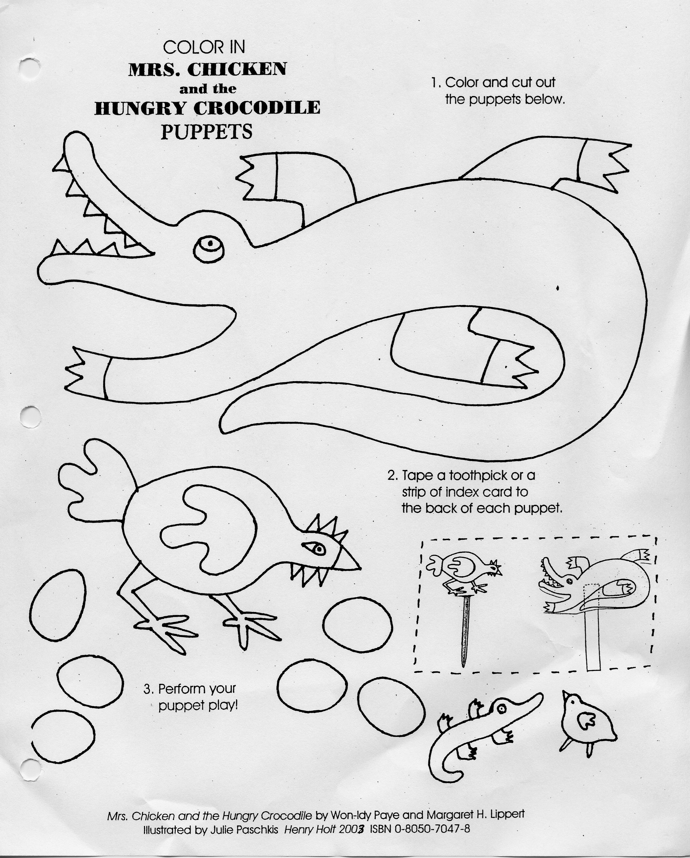

Washington Children’s Choice Picture Book Award Ballot 2005

Mail your ballot to Kristin Galante, c/o WCCPBA, Lynndale Elementary, 7200 191st SW, Lynnwood, WA 98036. To email this Word ballot, first save it to your computer. Fill out the information below, and send it as an attachment to galantek@edmonds.wednet.edu. Results will be posted on the WLMA webpage around April 15th.
• Remember to list the titles in ABC order by title with the total votes beside each title, your school name, town, District and total children voting. Thank you.

School Name/District: __________________________________________________________

City: ____________________________ Total Children Voting: ________________________

Title | Vote totals

An Interview with Harry the Tarantula
Boxes for Katje
Bubba and Beau Best Friends
Buster
Day the Babies Crawked Away
Diary of a Worm
Finklehopper Freog
Giant Children
Grumblebunny
How I Became a Pirrate
Mary Smith
Mother to Tigers
Mrs. Chicken and the Hungry Crocodile
My Lucky Day
My Name i8s Yoon
Sixteen Cows
Skippyjonjones
Snowmen at Night
Stone Soup
What Do You Do With a Tail Like This?
Battle of the Books activity for grades 4-6th

• Older students who have participated in WCCPBA really get into this activity.
• In the spring after voting gather up several copies of each of the WCCPBA titles
• Divide each class into five teams
• Put a selection of the books in 5 tubs around the room
• For three weeks have each team read all 20 titles
• On the fourth week have the “Battle” where you ask questions and the teams answer the questions on an answer sheet. The answer is always the title of one of the books.

Materials needed:
• 5 teams for each class
• At least two copies of each title, if possible three (I get some from public library)
• List of titles for each team with spaces to add the initials of members as they read the books
• I use the title list to determine which books go in which tubs each week
• List of questions (I usually come up with about 30) to ask during “Battle” week.

• Below are the rules I put at each team space along with the team number or name:

Rules for preparing for the "Battle"
• 5 teams
• Each team must have read all the books (at least 2 people read each book in case someone is absent on the "Battle Day")
• Teams will be given 2-3 weeks to read all 20 of the books
• Team members may come in at recess to read the books
• Teams must be prepared to answer questions about the books on "Battle" day

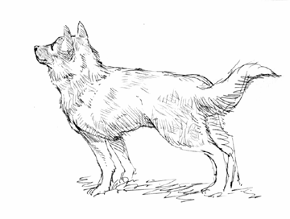

Dear Readers of Washington State,

Thank you one time, thank you two times and thank you three times for
selecting my book TOGO for the Washington State Children’s Choice Award.

Thank you one time, from me, because I am honored that you like my book.
I had a wonderful time traveling to Alaska and following in Togo’s footsteps. I worked hard on the story and enjoyed painting the pictures.

Thank you two times, from Togo’s master, Leonhard Seppala, who would be
very pleased. It always bothered him that Balto got the credit for getting
the life saving serum to Nome. Mr. Seppala felt that it was his other dog,
Togo, who did most of the work. He spent the rest of his life trying to make
the world aware of the fact that, although Balto ran into Nome with the life saving serum, Togo was the real hero.

And thank you three times, from Togo himself. Even though people doubted
him, he absolutely and completely believed in himself. He never gave up no
matter how much rejection he received. He gave every last bit of his strength
and spirit to help the people of Nome. Even though Togo was a dog, he knew
that his life had a purpose.

So, thank you from me, thank you from Leonhard Seppala and thank you from Togo.

Sincerely,
Robert J. Blake

* this activity packet is a group effort. Committee members have submitted the activities for you and your students to enjoy.

